

**Reva Business School**

Major Project Proposal

On

**“A STUDY ON THE SUSTAINABILITY MANAGEMENT AND FINANCIAL PERFORMANCE OF INDIAN DESIGNS EXPORTS PVT LTD.”**

**Master of Business Administration**

Submitted By

**SANDHYA K**

**R20MB156**

Under the guidance of

**Dr. SHAKTI CHATURVEDI**

Associate Professor

**August 2022**

**Rukmini Knowledge Park, Kattigenahalli, Yelahanka, Bengaluru-560064**

**DATA ANALYSIS AND INTREPRETATION**

**RATIO ANALYSIS**

**Current Ratio:**

The link between current assets and current liabilities is established by the current ratio. It tries to assess a company's capacity to satisfy present obligations. The following formula is used to calculate this ratio:

Current ratio = current assets / current liabilities

|  |  |  |  |
| --- | --- | --- | --- |
| **Year** | **Current Assets** | **Current Liabilities** | **Current Ratio** |
| 2017 | 7453.18 | 4093.33 | 1.8 |
| 2018 | 8848.18 | 4343.32 | 2.0 |
| 2019 | 8115.64 | 4130.36 | 1.9 |
| 2020 | 8288.56 | 3976.06 | 2.0 |
| 2021 | 10952.79 | 6110.22 | 1.7 |

**Table 1: showing current ratio (in crores)**

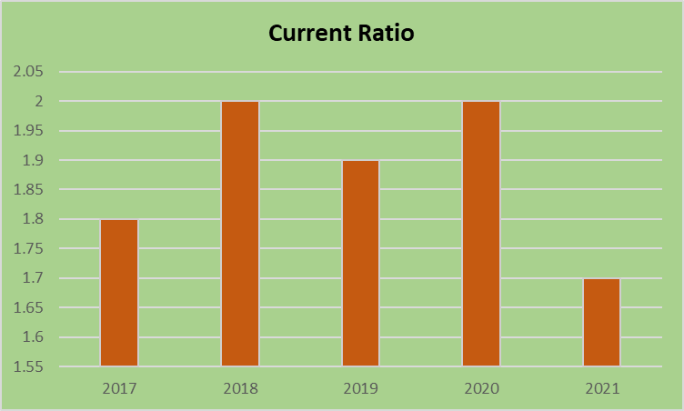

**INTREPRETATION:**

* According to the usual rule of current ratio 2:1, the performance of the current ratio in 2017 was 1.8 percent, and it increased to 2.0 percent in 2018, but declined to 1.7 percent in 2021.
* The current ratio is used to assess the connection between current assets and current liabilities.

**Liquidity Ratio:**

The liquidity ratio, usually known as the acid test or fast ratio, is a measurement of the quantity of liquid in a container. It is utilized in addition to the existing ratio. The acid test ratio is a more severe and demanding review of a company's ability to pay its short-term commitments on schedule. The liquidity ratio establishes the relationship between current commitments and liquid assets. The formula mentioned below is used to compute this ratio.

liquidity ratio = Current assets – (stock and prepaid expenses) /current liabilities

|  |  |  |  |
| --- | --- | --- | --- |
| **Year** | **Quick Assets** | **Current Liabilities** | **Liquidity Ratio** |
| 2017 | 6796.87 | 4093.33 | 1.6 |
| 2018 | 8024.6 | 4343.32 | 1.8 |
| 2019 | 7043.27 | 4130.36 | 1.7 |
| 2020 | 7196.59 | 3976.06 | 1.8 |
| 2021 | 9483.24 | 6110.22 | 1.5 |

**Table 2. Showing Liquidity Ratio (in crores)**

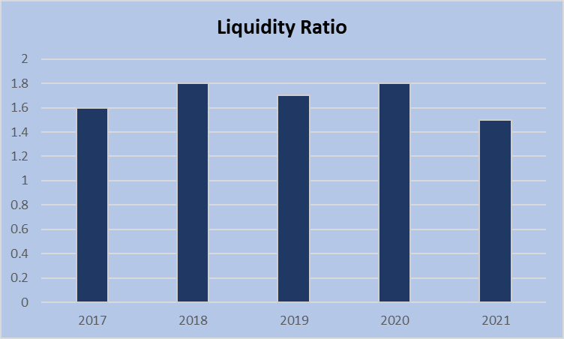

**INTREPRETATION:**

* The liquidity ratio 1:1. The above table that indicates the liquidity ratio of the company. In 2017 it was 1.6 and it has increased to 1.8 trends from 2018 to 2020. Then it decreased to 1.5 in the year 2021. A liquidity ratio 1:1 is considered to be satisfactory.
* The Liquidity Ratio of the firm is good

**CASH POSITION RATIO**

The cash ratio (also known as the cash asset ratio) is the amount of cash and cash equivalent assets a corporation has relative to its total liabilities. The cash ratio is a modification of the quick ratio that demonstrates how soon easily available money may be utilized to pay down current commitments. The most severe and cautious of the three liquidity requirements is the cash ratio (current, quick and cash ratio) (current, quick and cash ratio).

Cash position ratio= cash and bank balance \ current liabilities

|  |  |  |  |
| --- | --- | --- | --- |
| **Year** | **Cash and Bank Balance** | **Current Liabilities** | **Cash position Ratio** |
| 2017 | 136.73 | 4093.33 | 0.03 |
| 2018 | 141.34 | 4343.32 | 0.03 |
| 2019 | 136.46 | 4130.36 | 0.03 |
| 2020 | 241.86 | 3976.06 | 0.06 |
| 2021 | 257.15 | 6110.22 | 0.04 |

**Table 3 showing cash position ratio (In crores)**

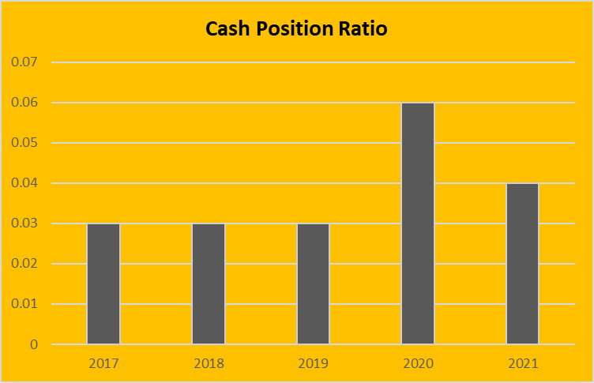

**INTREPRETATION**

* The Cash Position Ratio is the proportion of current assets to current liabilities. Between 0.2 and 0.5 is the optimum range.
* In the above table it shows cash position of the company in 2017 to 2019 remains constant it was 0.03 percentage and it has increased in 2020 with 0.06 percentage

**NET PROFIT RATIO**

The net profit ratio is also known as the profit margin ratio or the sales ratio from net profit. This ratio represents the overall capacity of the organization to execute its operations. The relationship between net profit (before or after taxes) and sales is calculated using the net profit ratio.

Non-operating returns and profits are included in net profit. Non-operating returns, such as dividends earned, are available after deducting income tax from production costs, other operating expenses and sales revenue. Profit or sales margin shows the amount available after deducting manufacturing cost, other operating expenses and income tax from sales revenue. The following formula can be used to obtain this ratio.

The net profit ratio is equal to the product of the net profit and the net sales multiplied by 100.

|  |  |  |  |
| --- | --- | --- | --- |
| **Year** | **Net profit** | **Net sales** | **Net Profit Ratio** |
| 2017 | 3377.12 | 28500.46 | 11.84 |
| 2018 | 3697.36 | 32230.49 | 11.47 |
| 2019 | 3384.87 | 33650.94 | 10.05 |
| 2020 | 3633.26 | 28836.09 | 12.59 |
| 2021 | 2964.20 | 30800.62 | 9.62 |

**Table 4 showing Net profit Ratio (In crores)**

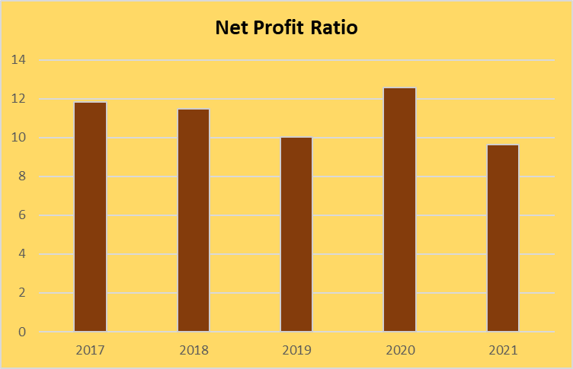

**INTREPRETATION:**

* It shows the efficiency of business as the net profit in 2017 it was 11.84 and it has fluctuating from 2018 to 2021.
* Then it decreases to 10.05 in the year 2019. So, this shows that the company has to increase the net profit has reducing the expenses.
* In the year 2021 there is a decrease in the ratio to 9.62.

**GROSS PROFIT RATIO**

Gross profit margin (GP ratio) is a financial statistic that divides a company's gross profit by its total net sales to determine its performance and efficiency. By multiplying the result by 100, the gross profit ratio can also be expressed as a percentage. Gross profit percentage or gross profit margin is used.

Gross profit = Gross profit / (Net sales × 100)

|  |  |  |  |
| --- | --- | --- | --- |
| **Year** | **Gross profit** | **Net sales** | **Gross profit ratio** |
| 2017 | 6578.19 | 28500.46 | 23.08 |
| 2018 | 6801.63 | 32230.49 | 21.10 |
| 2019 | 7500.32 | 33650.94 | 22.28 |
| 2020 | 8294.16 | 28836.09 | 28.76 |
| 2021 | 9668.7 | 30800.62 | 31.39 |

**Table 5 showing gross profit ratio (In crores)**

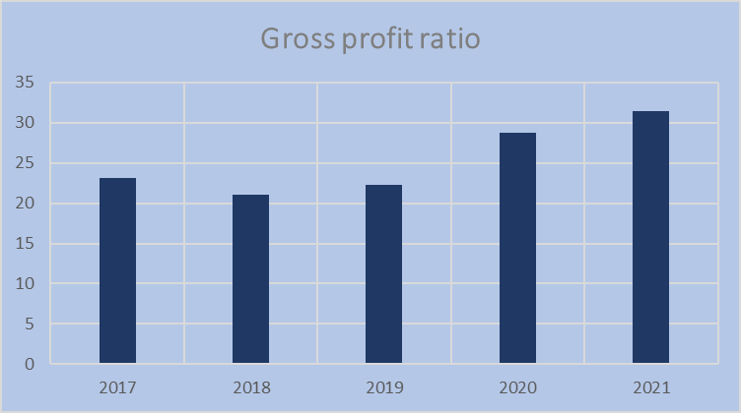

**INTREPRETATION**

* A bigger gross profit margin suggests that a business can profitably sell its products.
* The Gross Profit Ratio position of Bellad Motors Private Limited Ltd. is shown in the table above. The Gross Profit Ratio ranged from 23.08 to 31.39 over the study period 2017-2021.

**EXPENSES RATIO**

The expenditure ratio (expense to sales ratio) is used to assess the relationship between a single cost or a group of costs and sales. The spending ratio is established by dividing a given cost or collection of costs by net sales. It is expressed in percentages.

Expense ratio = total expenses / net sales *100

|  |  |  |  |
| --- | --- | --- | --- |
| **Year** | **Total Expenses** | **Net Sales** | **Expenses ratio** |
| 2017 | 24364.43 | 28500.46 | 85.48 |
| 2018 | 27512.15 | 32230.49 | 85.36 |
| 2019 | 29331.06 | 33650.94 | 87.16 |
| 2020 | 25718.11 | 28836.09 | 89.18 |
| 2021 | 27480.09 | 30800.62 | 89.21 |

**Table 6 showing Expenses ratio (In crores)**

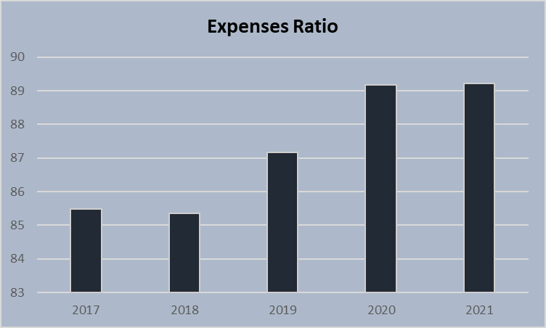

**INTREPRETATION:**

As a result, the corporation must cut costs. There are many types of expenditure ratios, including gross expense ratio and net expense ratio. Expenses should be limited to a minimum rather than a maximum. In 2017, the figure was 85.48, and it is expected to rise from 2019 to 2021.

**RETURN ON CAPITAL EMPLOYED**

Return on capital employed is a profitability ratio that compares net operating profit to capital employed to assess how effectively a business can make profit from its capital spent.

EBIT/capital employed Equals return on capital employed total assets less current liabilities equals capital used.

|  |  |  |  |
| --- | --- | --- | --- |
| **Year** | **EBIT** | **Capital Employed** | **Return on Capital Employed** |
| 2017 | 4658.46 | 10600.93 | 44.00 |
| 2018 | 5244.16 | 12395.48 | 42.35 |
| 2019 | 5010.73 | 13510.83 | 37.15 |
| 2020 | 3896.32 | 14773.27 | 26.52 |
| 2021 | 3900.38 | 16050.83 | 24.43 |

**Table 7 showing Return on Capital Employed (In crores)**

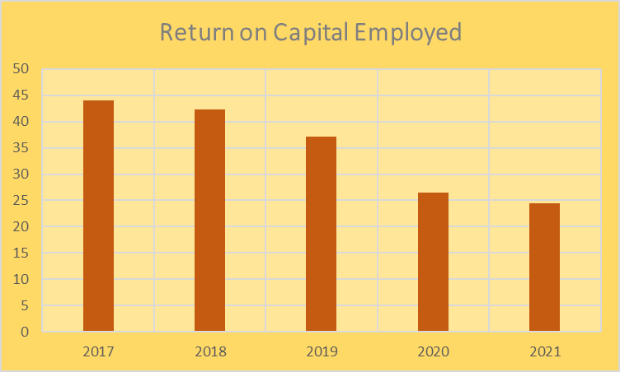

**INTREPRETATION**

* The return on capital employed in 2017 it was 44 and it has decreasing in 2018 was 42.35. Then it decreasing trends from 2019 to 2021. It shows the return capital employed decreased.
* so company has to maintain the capital employed in future growth.

**RETURN ON ASSETS**

Return on assets is a measure of a company's profitability in proportion to its total assets. Return on assets reflects how successful management is in earning income from its assets. The return on assets may be computed using a formula.

Return on assets = net income\ total assets

|  |  |  |  |
| --- | --- | --- | --- |
| **Year** | **Net Income** | **Total Assets** | **Return On Assets** |
| 2017 | 337674 | 14694.26 | 22.98 |
| 2018 | 369592 | 16738.80 | 22.08 |
| 2019 | 338358 | 17641.19 | 19.18 |
| 2020 | 363174 | 18749.33 | 19.37 |
| 2021 | 296293 | 22161.05 | 13.37 |

**Table 8 showing Return on Assets (In Crores)**

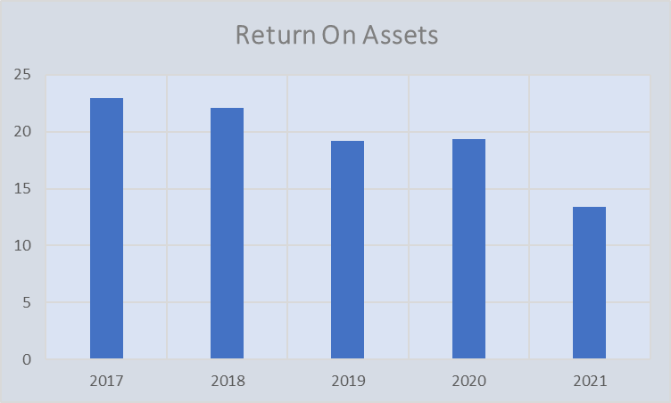

**INTREPRETATION**

* This demonstrates that the company's assets have not been put to work to create profits.
* The overall asset return In 2017, the rate of return on assets was 22.98 percent, with falling trends from 2018 to 2021.

**TOTAL ASSETS TURNOVER RATIO**

The ratio of a company's sales to its assets is known as the asset turnover ratio. It's an efficiency ratio that assesses how successfully a corporation utilises its assets to earn money.

Total assets turnover ratio = net sales / total assets

|  |  |  |  |
| --- | --- | --- | --- |
| **Year** | **Net Sales** | **Total Assets** | **Total assets turnover ratio** |
| 2017 | 28500.46 | 14694.26 | 1.93 |
| 2018 | 32230.49 | 16738.80 | 1.92 |
| 2019 | 33650.94 | 17641.19 | 1.90 |
| 2020 | 28836.09 | 18749.33 | 1.53 |
| 2021 | 30800.62 | 22161.05 | 1.38 |

**Table 9 showing total assets turnover ratio (In crores)**

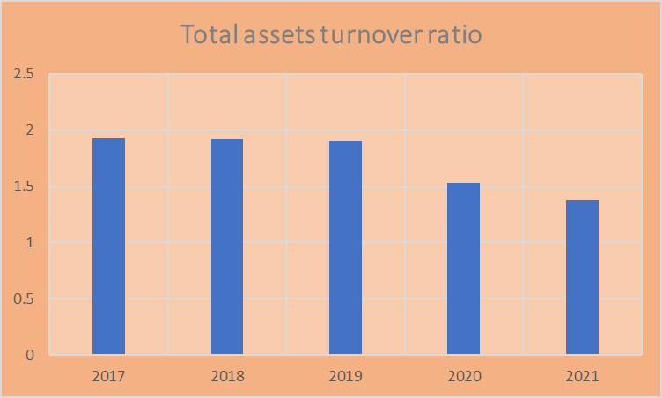

**INTERPRETATION:**

* In 2017, the asset turnover ratio was 1.93. Next, from 2018 to 2021, it will display declining models.
* Low ratios indicate that the company is not utilizing its assets effectively and is more prone to maintenance or production problems.
* This ratio assesses how well a company utilizes its assets to create revenue, with a greater ratio always being preferable.

**PROPRIETARY RATIO**

The ownership ratio (also known as the net worth ratio or equity ratio) is used to assess the stability of a firm's capital structure. Divide the shareholder's equity by the total assets to compare. Shareholder money / total direct assets = ownership ratio

|  |  |  |  |
| --- | --- | --- | --- |
| **Year** | **Shareholder’s fund** | **Total tangible assets** | **Proprietary ratio** |
| 2017 | 10111.29 | 4310.73 | 2.34 |
| 2018 | 11768.88 | 4485.89 | 2.62 |
| 2019 | 12857.12 | 4477.53 | 2.87 |
| 2020 | 14136.40 | 5976.00 | 2.36 |
| 2021 | 15198.43 | 5698.15 | 2.66 |

**Table 9 showing proprietary Ratio (In crores)**

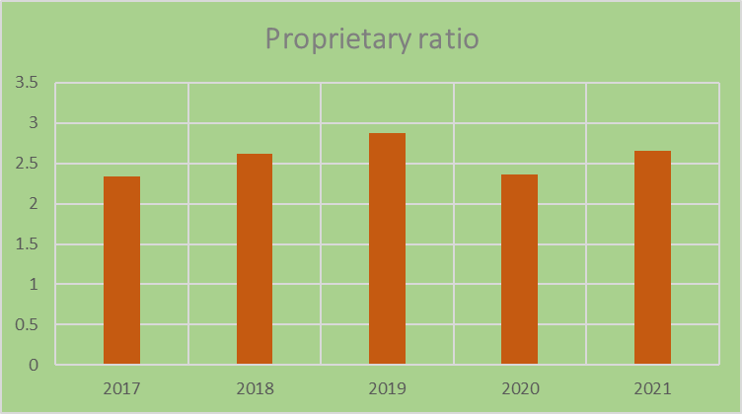

**INTREPRETATION**

* In 2017, the proprietary ratio was 2.34, and it has risen since then. Then, from 2018 to 2021, it will be on an upward trend. It demonstrates that in the year 2019, the proprietary ratio increased somewhat.
* A higher ownership ratio, on the other hand, indicates a firm financial position and better security for creditors; The low ratio, on the other hand, indicates that the company’s operations are already significantly dependent on debt.
* The proprietary ratio depicts the contribution of shareholders to the company's total capital.

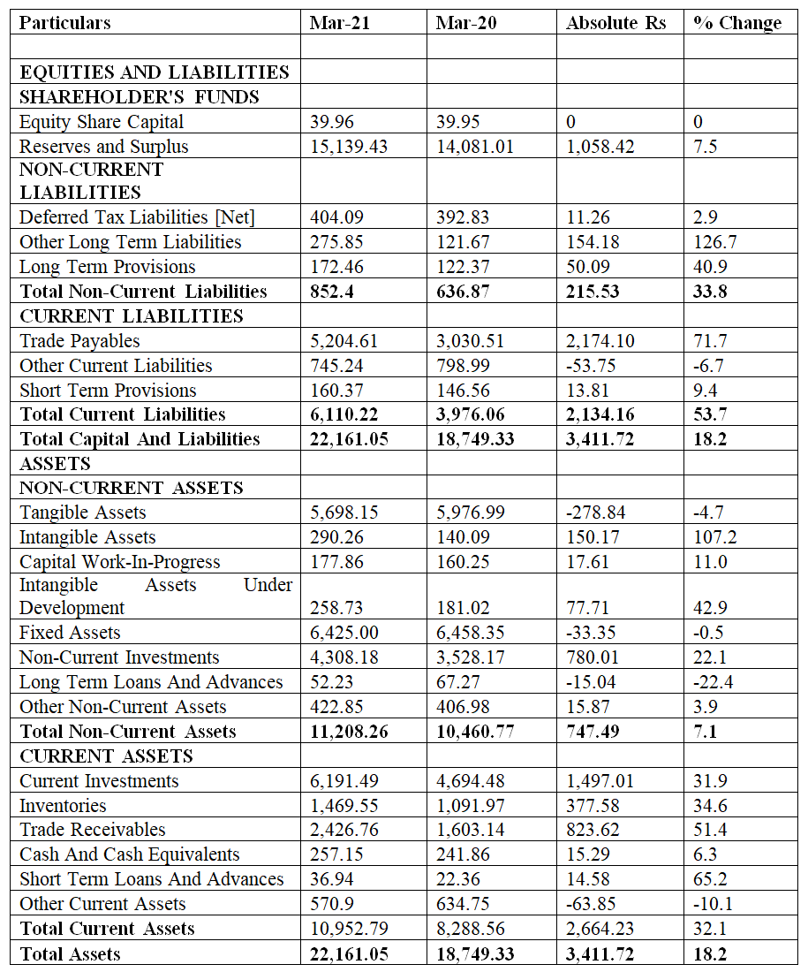**COMPARATIVE BALANCE SHEET OF INDIAN DESIGNS PRIVATE LTD (In crores)**

**COMPARATIVE INCOME STATEMENT INDIAN DESIGNS PRIVATE LIMITED (In Crores)**

|  |  |  |  |  |
| --- | --- | --- | --- | --- |
| **Particulars** | **Mar 21** | **20-Mar** | **Absolute changes RS** | **% of Changes** |
| **INCOME** |  |  |  |  |
| Revenue From Operations [Gross] | 30,303.53 | 28,408.43 | 1,895.10 | 6.67 |
| Less: Excise/Sevice Tax/Other Levies | 0 | 0 | 0.00 | 0.00 |
| **Revenue From Operations [Net]** | **30,303.53** | **28,408.43** | **1,895.10** | **6.67** |
| Other Operating Revenues | 497.09 | 427.66 | 69.43 | 16.23 |
| Total Operating Revenues | 30,800.62 | 28,836.09 | 1,964.53 | 6.81 |
| Other Income | 579.85 | 778.34 | -198.49 | -25.50 |
| **Total Revenue** | **31,380.47** | **29,614.43** | **1,766.04** | **5.96** |
| **EXPENSES** |  |  |  |  |
| Cost Of Materials Consumed | 21,875.33 | 19,867.19 | 2,008.14 | 10.11 |
| Purchase Of Stock-In Trade | 30.46 | 0 | 30.46 | 0.00 |
| Changes In Inventories Of FG, WIP And Stock-In Trade | -143.46 | -169.78 | 26.32 | -15.50 |
| Employee Benefit Expenses | 1,898.72 | 1,841.70 | 57.02 | 3.10 |
| Finance Costs | 21.84 | 22.02 | -0.18 | -0.82 |
| Depreciation And Amortization Expenses | 676.87 | 817.96 | -141.09 | -17.25 |
| Other Expenses | 3,120.33 | 3,339.02 | -218.69 | -6.55 |
| **Total Expenses** | **27,480.09** | **25,718.11** | **1,761.98** | **6.85** |
| Profit/Loss Before Exceptional, ExtraOrdinary Items And Tax | 3,900.38 | 3,896.32 | 4.06 | 0.10 |
| Exceptional Items | 0 | 677.37 | -677.37 | -100.00 |
| **Profit/Loss Before Tax** | **3,900.38** | **4,573.69** | **-673.31** | **-14.72** |
| Tax Expenses-Continued Operations |  |  | 0.00 | 0.00 |
| Current Tax | 924.92 | 1,084.11 | -159.19 | -14.68 |
| Deferred Tax | 11.26 | -143.68 | 154.94 | -107.84 |
| **Total Tax Expenses** | **936.18** | **940.43** | **-4.25** | **-0.45** |
| Profit/Loss After Tax and Before Extraordinary Items | 2,964.20 | 3,633.26 | -669.06 | -18.41 |
| Profit/Loss from Continuing Operations | 2,964.20 | 3,633.26 | -669.06 | -18.41 |
| Profit/Loss For The Period | 2,964.20 | 3,633.26 | -669.06 | -18.41 |

**INDIAN DESIGNS PRIVATE LIMITED LTD COMMON SIZE BALANCE SHEET (Rs in Crores)**

|  |  |  |  |  |
| --- | --- | --- | --- | --- |
| **Particulars** | **Mar-21** | **Common size%** | **Mar-20** | **Common size%** |
|  |  |  |  |  |
| **EQUITIES AND LIABILITIES** |  |  |  |  |
| **SHAREHOLDER'S FUNDS** |  |  |  |  |
| Equity Share Capital | 39.96 | 0.2 | 39.95 | 0.2 |
| Reserves and Surplus | 15,139.43 | 68.3 | 14,081.01 | 75.1 |
| **NON-CURRENT LIABILITIES** |  |  |  |  |
| Deferred Tax Liabilities [Net] | 404.09 | 1.8 | 392.83 | 2.1 |
| Other Long-Term Liabilities | 275.85 | 1.2 | 121.67 | 0.6 |
| Long Term Provisions | 172.46 | 0.8 | 122.37 | 0.7 |
| **Total Non-Current Liabilities** | **852.4** | 3.8 | **636.87** | 3.4 |
| **CURRENT LIABILITIES** |  |  |  |  |
| Trade Payables | 5,204.61 | 23.5 | 3,030.51 | 16.2 |
| Other Current Liabilities | 745.24 | 3.4 | 798.99 | 4.3 |
| Short Term Provisions | 160.37 | 0.7 | 146.56 | 0.8 |
| **Total Current Liabilities** | **6,110.22** | 27.6 | **3,976.06** | 21.2 |
| **Total Capital and Liabilities** | **22,161.05** | 100.0 | **18,749.33** | 100.0 |
| **ASSETS** |  |  |  |  |
| **NON-CURRENT ASSETS** |  |  |  |  |
| Tangible Assets | 5,698.15 | 25.7 | 5,976.99 | 31.9 |
| Intangible Assets | 290.26 | 1.3 | 140.09 | 0.7 |
| Capital Work-In-Progress | 177.86 | 0.8 | 160.25 | 0.9 |
| Intangible Assets Under Development | 258.73 | 1.17 | 181.02 | 1.0 |
| Fixed Assets | 6,425.00 | 28.99 | 6,458.35 | 34.4 |
| Non-Current Investments | 4,308.18 | 19.44 | 3,528.17 | 18.8 |
| Long Term Loans And Advances | 52.23 | 0.24 | 67.27 | 0.4 |
| Other Non-Current Assets | 422.85 | 1.91 | 406.98 | 2.2 |
| **Total Non-Current Assets** | **11,208.26** | **50.58** | **10,460.77** | **55.8** |
| **CURRENT ASSETS** |  |  |  |  |
| Current Investments | 6,191.49 | 27.94 | 4,694.48 | 25.0 |
| Inventories | 1,469.55 | 6.63 | 1,091.97 | 5.8 |
| Trade Receivables | 2,426.76 | 10.95 | 1,603.14 | 8.6 |
| Cash And Cash Equivalents | 257.15 | 1.16 | 241.86 | 1.3 |
| Short Term Loans and Advances | 36.94 | 0.17 | 22.36 | 0.1 |
| Other Current Assets | 570.9 | 2.58 | 634.75 | 3.4 |
| **Total Current Assets** | 10,952.79 | 49.42 | 8,288.56 | 44.2 |
| **Total Assets** | **22,161.05** | 100.00 | **18,749.33** | 100.0 |

**COMMON SIZE INCOME STATEMENT OF INDIAN DESIGN PRIVATE LIMITED (In Crores)**

|  |  |  |  |  |
| --- | --- | --- | --- | --- |
| **Particulars** | **Mar-21** | **COMMON SIZE %** | **Mar-20** | **COMMON SIZE %** |
| **INCOME** |  |  |  |  |
| Revenue From Operations [Gross] | 30,303.53 | 100 | 28,408.43 | 100 |
| Less: Excise/Service Tax/Other Levies | 0 | 0.0 | 0 | 0 |
| Revenue From Operations [Net] | 30,303.53 | 100.0 | 28,408.43 | 100 |
| Other Operating Revenues | 497.09 | 1.6 | 427.66 | 1.5 |
| **Total Operating Revenues** | **30,800.62** | **101.6** | **28,836.09** | **101.5** |
| Other Income | 579.85 | 1.9 | 778.34 | 2.7 |
| **Total Revenue** | **31,380.47** | **103.6** | **29,614.43** | **104.2** |
| **EXPENSES** |  |  |  |  |
| Cost Of Materials Consumed | 21,875.33 | 72.2 | 19,867.19 | 69.9 |
| Purchase Of Stock-In Trade | 30.46 | 0.1 | 0 | 0.0 |
| Changes In Inventories Of FG, WIP And Stock-In Trade | -143.46 | -0.5 | -169.78 | -0.6 |
| Employee Benefit Expenses | 1,898.72 | 6.3 | 1,841.70 | 6.5 |
| Finance Costs | 21.84 | 0.1 | 22.02 | 0.1 |
| Depreciation And Amortization Expenses | 676.87 | 2.2 | 817.96 | 2.9 |
| Other Expenses | 3,120.33 | 10.3 | 3,339.02 | 11.8 |
| **Total Expenses** | **27,480.09** | **90.7** | **25,718.11** | **90.5** |
| Profit/Loss Before Exceptional, Extraordinary Items And Tax | 3,900.38 | 12.9 | 3,896.32 | 13.7 |
| Exceptional Items | 0 | 0.0 | 677.37 | 2.4 |
| Profit/Loss Before Tax | 3,900.38 | 12.9 | 4,573.69 | 16.1 |
| Tax Expenses-Continued Operations |  |  |  |  |
| Current Tax | 924.92 | 3.1 | 1,084.11 | 3.8 |
| Deferred Tax | 11.26 | 0.0 | -143.68 | -0.5 |
| **Total Tax Expenses** | **936.18** | **3.1** | **940.43** | **3.3** |
| Profit/Loss After Tax And Before Extraordinary Items | 2,964.20 | 9.8 | 3,633.26 | 12.8 |
| Profit/Loss from Continuing Operations | 2,964.20 | 9.8 | 3,633.26 | 12.8 |
| Profit/Loss for The Period | 2,964.20 | 9.8 | 3,633.26 | 12.8 |

# FINDINGS

* The current ratio is used to estimate the relationship between current assets and current liabilities. As a general rule, the current ratio of 2: 1 is that the current ratio performance in 2017 was 1.8 percent, increased to 2.0 percent in 2018, but decreased to 1.7 percent in 2021.
* Gross Profitability Ratio (GPR). During the 2017-2021 research period, the gross profit ratio ranged from 23.08 to 31.39. A large gross profit margin indicates that the company can sell its products profitably.
* Costs should be minimized rather than maximized; In 2017, it was 85.48 and it is projected to increase from 2019 to 2021. As a result, the company has to cut costs. There are a variety of cost ratios, including the gross cost ratio and the net cost ratio.
* In 2017, the return on capital was 44, but in 2018 it dropped to 42.35. After that, from 2019 to 2021, it will be on a downward trend. Shows that the capital used for the return is reduced. As a result, the company must secure the money invested in future expansion.
* In 2017, return on total assets was 22.98 per cent, with declining trends from 2018 to 2021. This indicates that the company assets have not been put into operation to generate revenue.
* The liquidity ratio is one to one. The liquidity ratio of the company is shown in the table above. It rose to 1.6 in 2017 and 1.8 from 2018 to 2020. After that it fell to 1.5 by 2021. A 1: 1 liquidity ratio is adequate. The company liquidity ratio is awesome.
* Cash position ratio is the ratio of current liabilities to current assets. The optimal range is between 0.2 and 0.5. In the table above, the company’s cash position remained stable at 0.03 percent from 2017 to 2019, and then increased to 0.06 percent in 2020.
* This shows the company’s potential as net profit fluctuated from 11.84 in 2017 and from 2018 to 2021. Then, in 2019, it dropped to 10.05. As a result, the company's net profit should increase while reducing costs. In 2021, the ratio dropped to 9.62.
* In 2017, the asset turnover ratio was 1.93. Then, from 2018 to 2021, declining patterns emerged.
* In 2017, the ownership was 2.34 per cent and it has been growing ever since. Then, from 2018 to 2021, it will be on an upward trend. This shows that the ownership percentage has increased somewhat in 2019.
* Propritory ratio describes the shareholder's contribution to the company's total capital. As a result, a higher ownership ratio indicates a stronger financial position of the company and greater security of creditors. The low ratio indicates that the company’s operations are already highly dependent on debt.
* Analysis of Comparative Revenue Statement As can be seen from the above, the sales volume of the company increased by 1895.10 cores or 6.67% over the previous year. Although other incomes are down 25.50 percent, the difference in absolute terms does not affect total revenue.
* A larger ratio is usually more profitable because it reflects how effectively the company uses its assets to generate revenue. Higher turnover rates indicate that the company is making good use of its assets. Low ratios indicate that the company is not making the best use of its resources and has more management or production issues.
* Examining the ‌ Standard Income Statement the company performed almost identical with the previous year's performance. Operating expenses fell 0.80% on sales, resulting in a 0.80% increase in operating profit over the previous year. Net PBDT was down 0.05 percent compared to last year's sales. PBT also increased by 16.1% compared to sales. As mentioned earlier, the company benefits from a reduction in operating costs.
* Balance Sheet Analysis of Standard Size As a result of the above, non-current assets increased by 55.8% compared to the previous year. Although current assets have grown in absolute terms, their percentage is down 4.2 percent from last year. Current responsibilities are also shown In a similar pattern, with a decrease of 6 percent. As a result, the financial position of the company is similar to the previous year.
* Total revenue rose 5.96 per cent, but the company's PBT fell 673.31 cores, or 14.72 per cent, compared to the previous year. Financing costs fell 0.82 percent, while other expenses fell 6.55 percent. Compared to last year, staff costs increased by 3.10%. As a result the company was able to maintain profitability over the previous year.

# RECOMMENDATIONS

* Indian Designs Private Limited performance throughout the study period was strong during the first four years, and the company was efficient in maintaining financial capacity to support all of its development and diversification plans.
* The firm should preserve liquid assets in order to strengthen its liquidity position in the future, as well as take the required actions to boost the company's earning capability.
* They should boost the company's short-term liquidity, which will assist them satisfy their existing obligations.
* The following were the recommendations made to the company:
* The firm has implemented the appropriate plan to increase net profit in the next years.

# CONCLUSIONS

Improving the financial performance of the company. One of these great companies is Indian Designs Private Limited.

During the year, the company was able to expand its sales and profits. This improved the company's operations. The net profit margin has improved, indicating that the company can manage costs more efficiently. The company's current assets are sufficient to cover its current liabilities. Indian Designs Private Limited. Largest market share in the textile market. As planned revenues increased, the company was a profitable endeavor from a shareholder perspective. Compared to previous years, earnings per share have also increased. In general, the company has been successful in meeting the demands of shareholders and customers.

In terms of financial performance, a company's success is determined by how external financial markets view and respond to it. The world of Khatib management is more complex and fast today. Financial managers need to understand how to make productive judgments while avoiding the useless ones.

# BIBLIOGRAPHY

**BOOKS AND ARTICLES**

* Account for managers/ Thakur Publication/ Reference Page no4.5-9.4 • Introductory accounts and finance for non-accountants/ D. K Chatterjee/ Himalaya publishing house/ page no6.8,6.10–6.16
* Financial Management/Dr.N.M. Vechalkar/ Nirali prakashan/ Reference page no7.13–7.23,4.3-4.4
* Financial Management/S.C. Kuchhal/ Chaitanya Publishing House/ 16th Edition manufacture 2007/ Reference page no7.2–7.4,7.18,7.21
* Financial Management, khan and Jain

**WEBSITES**

* [www.oppappers.net](http://www.oppappers.net)
* [www.scribd.com](http://www.scribd.com)
* [www.slidesshare.net](http://www.slidesshare.net)
* https//planergy.com/blog/ratio-analysis-of-financial-statements/
* https//en.wikipedia.org/wiki/Financial_statement_analysis
* Financial Management – I.M.Pandey .
* [www.Moneycontrol.com](http://www.Moneycontrol.com).

# ANNEXURES

**Balance sheet of Indian Designs Private Limited LTD for the year 2017, 2018, 2019, 2020 & 2021**

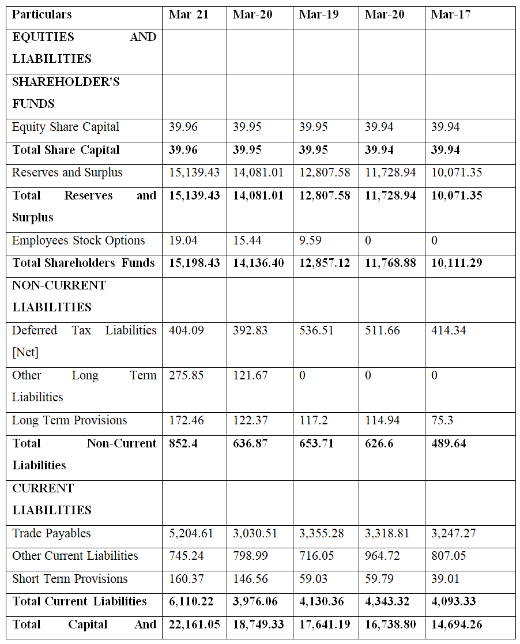

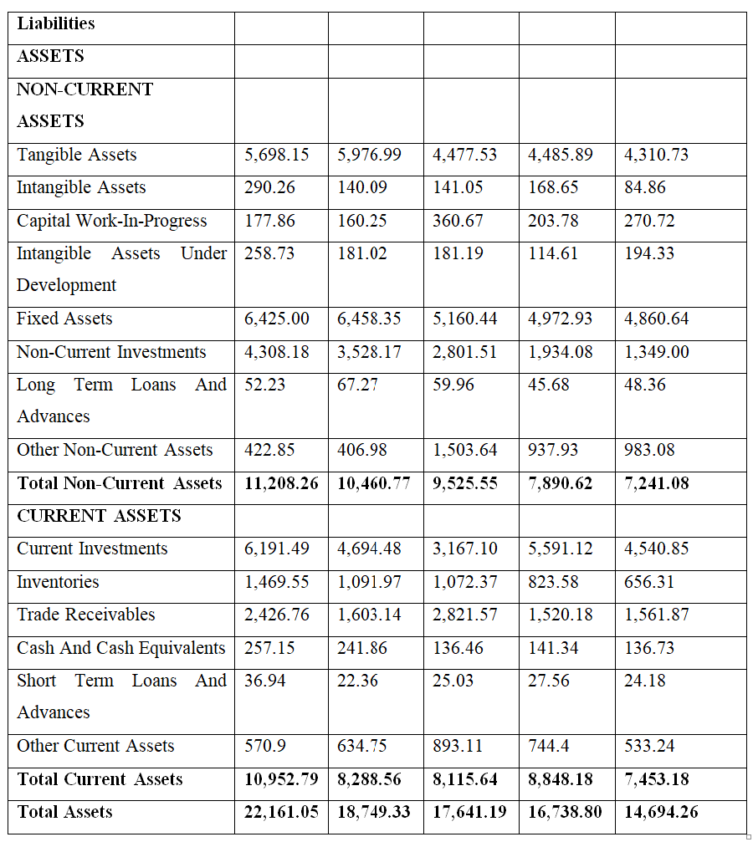

**Indian Designs Private Limited profit and loss account for the years 2017, 2018, 2019, 2020, and 2021**

